Collections Synopsis

Goals

- Be familiar with the Java Collections framework
- Understand the differences between
  - Interfaces
  - Abstract Classes
  - Concrete Classes
- Understand what it means to buy a collection
- Be familiar with the Collections and Arrays classes
- Understand the usages of Comparable and Comparator and the concept of natural ordering
- Be able to effectively use Iterators
- Understand how to preserve state while testing a potential scenario using a cloned Collection

Patterns

- Buy collections for solutions
- Creating meaningful (business) names for the operations passed on to the bought collection
- Using the weakest collection that will do the job

Anti-patterns

- Breaking encapsulation by using stronger typed collections than what is necessary
- Wrapping data to store in a collection when the resulting wrapped object provides no kick
- Overriding equals(Object)without overriding hashCode()

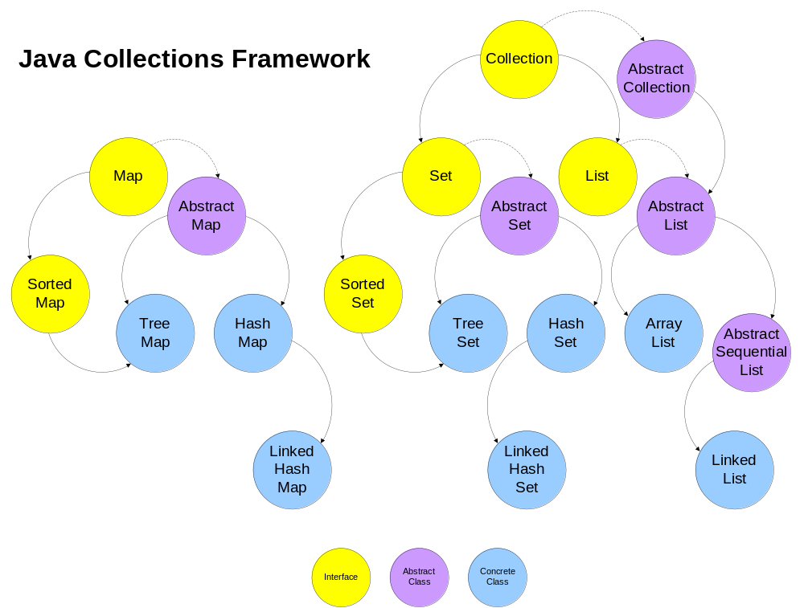

 | Interface | Abstract Class | Concrete Class
Visibility | Public | Package  Public  (Less if Inner) | Package  Public  (Less if Inner)
Can Instantiate | No | No | Yes
Method Types | Declarations | Abstract  Concrete | Concrete
Method Visibility | Public | Any | Any
Can Have  Attributes | No | Yes | Yes
Can Have  Constants | Yes | Yes | Yes

